Mac OS X: How to add a network printer

Mac OS X v10.5 or later
- Choose System Preferences from the Apple menu.

- Choose Print & Fax from the View menu.
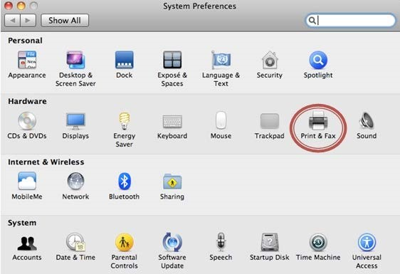
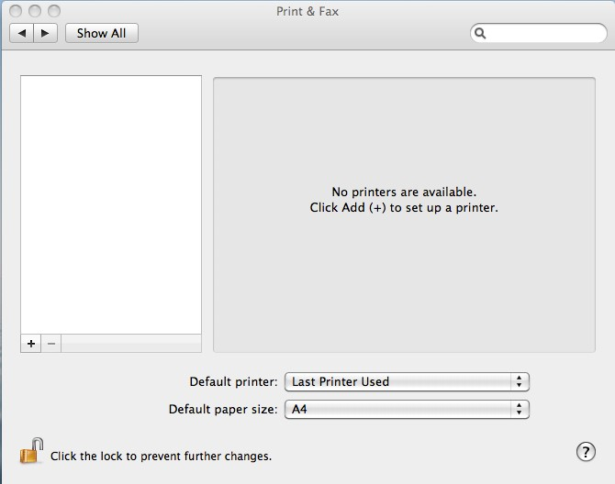
3.

Click the
+
button to add a printer.

- Press the [Control] key while clicking the "Default" icon (or any other icon on the toolbar), then choose Customize Toolbar from the contextual menu that appears.
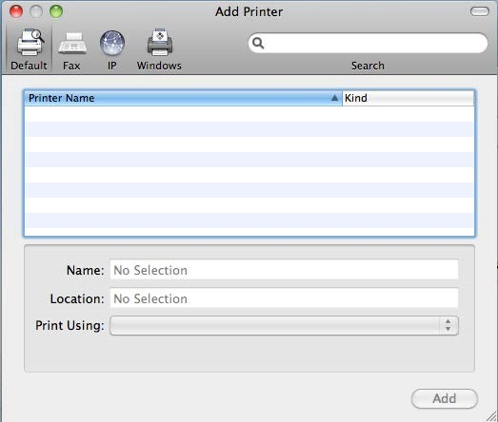

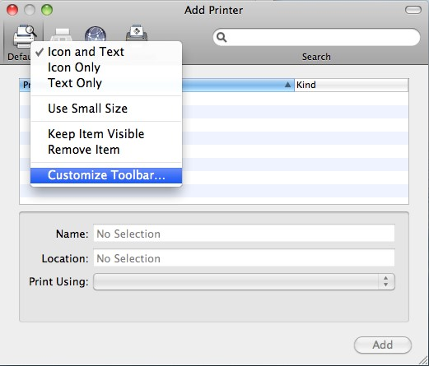

- Drag the Advanced (gear) icon to the toolbar.
- Click [Done].
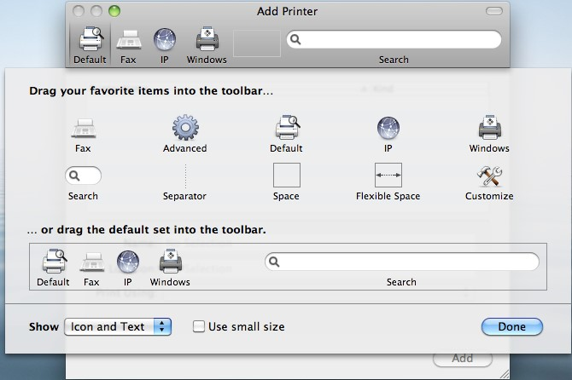

- Click the [Advanced] icon that was added to the toolbar.
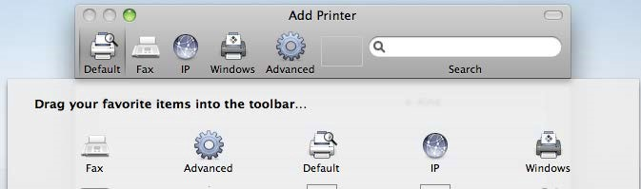

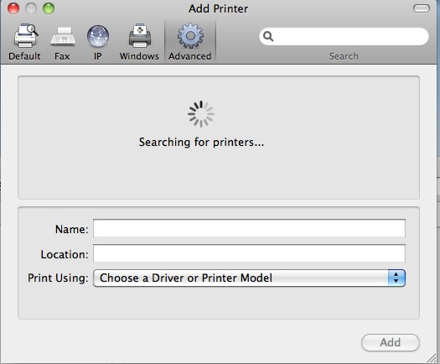

- Choose Windows from the Type pop-up menu.
- In the URL field, type the printer name (e.g. CSU00012).
- In the Name field, type the name you would like to use for this printer in Mac OS X.
- Choose the appropriate PPD or printer driver from the "Print Using" pop-up menu.
- Click [Add].
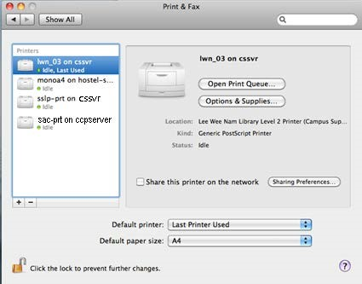
Note:
    - After sending print job to the respective print queue, the job is always on hold. Open up the print queue and click [Resume] to release the job.
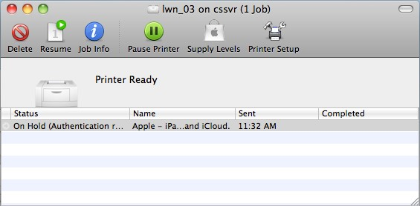

    - When prompt for username and password, please enter your network id and password.
